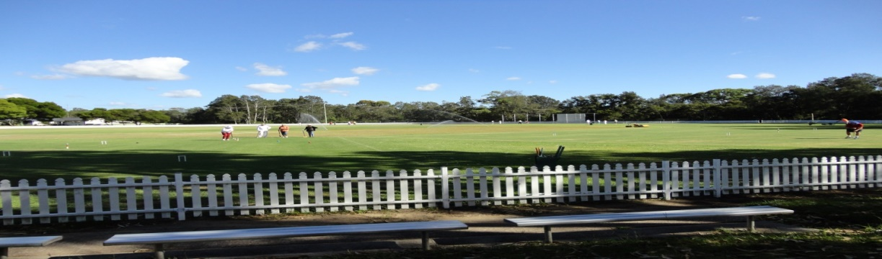
Toronto Croquet Club &Lake Macquarie City Council present
LAKE MACQUARIE GAMES
At Ron Hill Oval, Toronto
GOLF CROQUET
DOUBLES: Monday 20TH August, 2018
SINGLES: Tuesday 21st, August 2018
RICOCHET DOUBLES
Wednesday: 22nd, August, 2018
Closing Dates for entries: 30th, July, 2018
Registration 8:00 Play starts 8:30 for each competition day
Morning and afternoon teas included. Lunches can be purchased each day.
GOLF CROQUET: Level play in seeded block play. Handicap cards will be used.
Players may nominate in pairs, or singly and be partnered with someone.
A limit of 6 players per club may be applied.

RICOCHET- Format to be advised once entry numbers are confirmed:1.5 hour games.
Handicaps (GC equivalent) will be used to assign blocks
A limit of four players per club may need to be applied
Players may nominate in pairs, or singly and be partnered with someone.

ENTRY FEE- GC: $15/person Doubles and $15/person Singles
ENTRY FEE- RICOCHET: $15/person
Enquiries: Kevin Davies – Ph. 02 49 592300
Please use this form for Golf and/or Ricochet Events

name |  |  | partner name
address |  |  | address
email |  |  | email
phone |  |  | phone
club |  |  | club
Handicap |  |  | Handicap
Index |  |  | Index
Able to referee |  | Y/N | Able to referee |  | Y/N
(please circle)
Fees payable
 | name | partner
Golf doubles $15pp
Golf singles $15pp
Ricochet $15pp
 | TOTAL

Please forward registration form to torontocroquetclub@yahoo.com.au
if payment made by direct debit to
BSB: 650 000 Account No 529 487 701. (Please include your surname & initial)

OR Post to: Tournament Coordinator, PO Box 369 TORONTO 2283 WITH FEE
With cheque made payable to Toronto Croquet Club

Please note late withdrawals, may not be entitled to a refund of entry fee.

