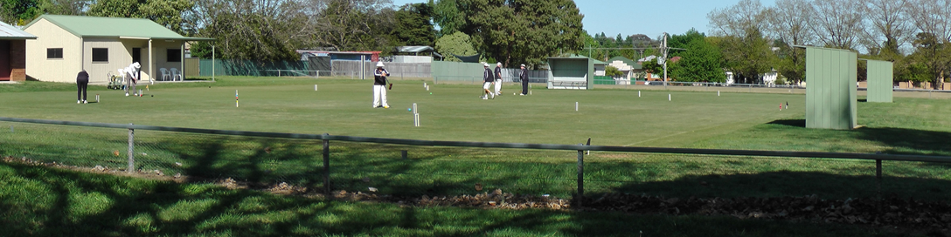
Orange City Croquet Club
Spring Golf Croquet Carnival
Handicap Doubles and Singles
Tuesday October 16th to Friday 19th 2018
Jaeger Reserve,
149 Hill Street Orange

Entries:
Maximum 24 players (Singles 3x8 Blocks Double 3 x 4 Blocks)
Entries accepted strictly in order of receipt of entry and payment
An initial limit of 6 players from one club
Doubles Partners will be allocated
Entry Fee:
$50.00 per player
Closing date: 9th October 2018
Practice and Registration:
Monday 15th October 2:30 to 4:30
Catering:
Morning and Afternoon tea provided
Lunches may be ordered on the day
Carnival Dinner Wednesday October 18th Venue TBA
Further Information Contact:
Tournament Secretary | Rik Mills | 04 3994 8198 / 02 6362 5592
Email: | orangecroquet@gmail.com
Postal Address: | Orange City Croquet Club, PO Box 8579, Orange East, NSW, 2800

ORANGE CITY CROQUET CLUB
GOLF CARNIVAL 2018

Entry Fee: 50 per person

Name:

Address:

Phone/Mobile: Email:

Club: ACA ID:

Handicap: Index:

Please make cheques payable to Orange City Croquet Club or
Direct Transfer to Orange City Croquet Club Inc. BSB: 802-129 A/C No. 43313.
Ensure you identify the transfer with your name and forward email confirming transfer to orangecroquet@gmail.com
Please Return this from to Tournament Secretary, PO Box 8579, Orange East, NSW, 2800

I CAN ASSIST WITH REFEREEING YES /NO

ORANGE CITY CROQUET CLUB
GOLF CARNIVAL 2018
Entry Fee: $50per person

Name:

Address:

Phone: Email:

Club: ACA ID:

Handicap: Index:

Please make cheques payable to Orange City Croquet Club or
Direct Transfer to Orange City Croquet Club Inc. BSB: 802-129 A/C No. 43313.
Ensure you identify the transfer with your name and forward email confirming transfer to orangecroquet@gmail.com
Please Return this from to Tournament Secretary, PO Box 8579, Orange East, NSW, 2800

I CAN ASSIST WITH REFEREEING YES /NO

