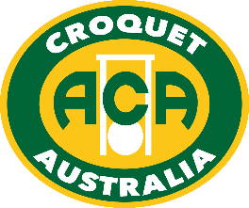

2019 Australian Golf Croquet
Handicap Doubles and Singles

Australia's major GC handicap event has moved to Albury
Monday 30th Sept to Friday 4th October 2019
Dates may vary depending upon the number of nominations. Play under lights may be required.
- Doubles - Monday 30 Sept and Tuesday 1 October
- Singles - Wednesday 2 to Friday 4 October

Note that the NSW GC Handicap Champs are 18-22 Sept at Canberra, so it is feasible for players to move on to Albury afterwards. Talk to your friends and other members of your Club; get a group together and encourage them to enter one of Australia’s most enjoyable national competitions.

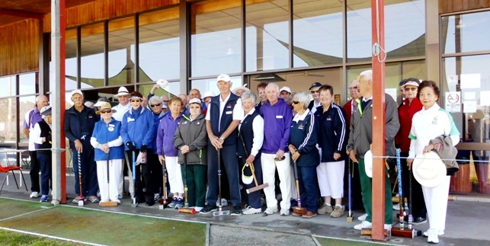

We are having problems with entry for this event on the Croquet Australia website, so please send an email to Peter Freer, Chair ACA Events, at: events@croquet-australia.com.au
and indicate if you are entering the GC Handicap Doubles and/or GC Handicap Singles.
You can nominate your own Doubles partner, or enter by yourself and ask for a partner.

Peter will send you back an entry form, plus instructions on how to pay.
Existing entries will in Entries, under this event on croquetscores.

If confused or have a query, just email.
Entries close midnight Thursday 12 September, 2019 (WA time)

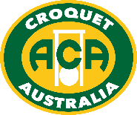

www.croquet-australia.com.au

Tournament Manager: Sarina Cevaal-Hewitt
Tournament Referee: TBC
Tournament Handicapper: Peter Freer
ACA Events: Peter Freer
Headquarters: Twin City Croquet Club, at the Albury Tennis Association,
365 Townsend Street, South Albury (8 courts – more if required).
Entries: By email to Events, at: events@croquet-australia.com.au
Closing Date for Entry: Thursday 12 September 2019
Entry fees: Doubles: $60 per player
Singles: $90 per player
Full time students (under 25) and players aged under 21 at 31 December 2019 are entitled to 50% reduction of the above fees.

Hoops: Both Quadway and cast iron hoops may be used, set to 3 ¾”.

Functions: Informal Barbeque: Sunday 29 September at 6.00pm.
Tournament Presentation after each final.
Tournament Dinner Friday 4 Oct, if enough demand.
Practice: By arrangement with organisers on Sunday afternoon 30 Sept,
and Tuesday if this does not interfere with the Doubles Final
Accommodation: Contact the organisers for advice on twincitycroquetclub@gmail.com
Catering: Tea & coffee; snacks & lunches available for purchase

Events
- Australian Golf Croquet Handicap Doubles (Holders: Barry Jennings & Stephen Condous)
30 Sept - 1 October. Entries are limited to 32 pairs in order of receipt. Players will be allocated a partner if entering without one. We expect play to commence in seeded blocks (up to 8 pairs per block). Qualifying pairs will be re-seeded for the knock out phase. Matches are single 13-point games except for knock-outs which will be best-of-3 if time permits. Matches will start untimed, but the manager may impose a time limit if necessary. There will be no plate event for pairs eliminated from the knock-out.
- Australian Golf Croquet Handicap Singles (Holder: Andy Davis, 2017 – not held in 2018)
2-4 October. Entries are limited to 64 players in order of receipt. Depending on entries we expect play to commence in seeded blocks (up to 8 players per block). Qualifying players will be re-seeded for the knock-out phase. Matches will be single 13-point games except that knock-outs will be best-of-3 if time allows. Players are expected to play up to 6 games and/or 7 rounds per day. Matches will start untimed, but the manager may impose a time limit if necessary. A plate will be held for players eliminated from the knock-out.
Conditions – the WCF 2018 GC Rules will be used. Detailed conditions are in the ACA Tournament Regulations & will be in the Event Program.
Tournament Regulation 26 - Handicapping
These tournaments are important in providing information about relative handicaps between States.
The Tournament Handicapper will be pro-active in correcting players’ handicaps during the events, where there are discrepancies between players’ ability and their current handicap.

www.croquet-australia.com.au

