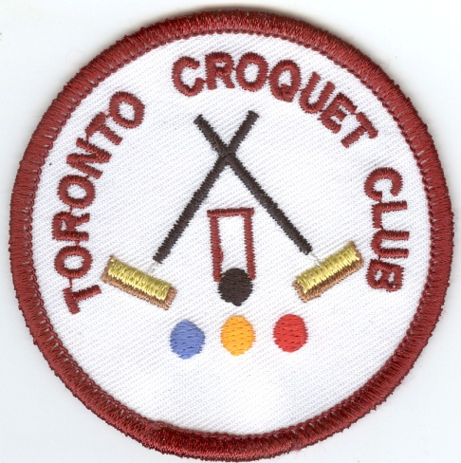
Toronto Croquet Club
Straight Ave Toronto NSW

GOLF CROQUET DOUBLES & SINGLES

Friday 31 July –Saturday 1 August 2015
(Closing date 10 July 2015)

Morning Tea and Registration 8:00 Play starts 8:30

- Limit of 8 players per club
- Doubles each morning followed by singles

$30 per person (includes morning and afternoon tea)

Enquiries: Kevin Davies Games Captain 4959 2300 –Michell Foo Games VC 4977 1357

Name: ACI-ID
Address or Email
Telephone Mobile number
Club: | Handicap: Index:
Referees: Would you be willing to assist Yes / No

Do you want to order lunch - Sandwiches at cost Yes / No

Name: ACI-ID
Address/Email
Telephone/Mobile number
Club: | Handicap: Index:
Referees: Would you be willing to assist Yes / No

Do you want to order lunch - Sandwiches at cost Yes / No

Visit our web site at https://sites.google.com/site/torontocroquetclub/home

Entries to: Secretary Toronto Croquet Club PO Box 369 Toronto NSW 2283 or torontocroquetclub@yahoo.com.au
Cheques made out to Toronto Croquet Club
For internet deposit A/C 781230863 BSB: 637000 Ref: your name 31JULY

