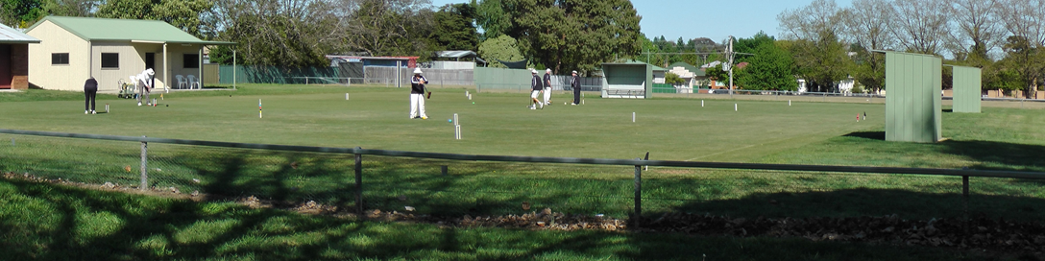
Orange City Croquet Club
Spring Golf Croquet Carnival
Handicap Doubles and Singles
15th to 18th September 2016
Jaeger Reserve, Hill Street Orange

Entries:
Maximum 24 players, entries accepted in order of receipt.
Entries accepted in order of receipt of player details and payment
A preliminary limit of 6 players from one club
Doubles Partners will be allocated

Entry Fee:
$45.00 per player
Closing date: 3rd September 2015

Practice and Registration:
Wednesday 14th September 2:30 to 4:30

Catering:
Morning and Afternoon tea provided
Lunches may be ordered on the day
Carnival Dinner Tuesday TBA

Further Information Contact Tournament Secretary:
Phone: Rik Mills 02 6362 5592 04 3994 8198
Email: orangecroquet@gmail.com
Postal Address: Orange City Croquet Club, PO Box 8579, Orange East, NSW, 2800

ORANGE CITY CROQUET CLUB GOLF CARNIVAL
September 15th – 18th 2016
Entry Fee: $45 per person

Name:

Address:

Phone: Email:

Club: ACA ID:

Handicap: Index:

Please make cheques payable to Orange City Croquet Club or
Direct Transfer to Orange City Croquet Club Inc. BSB: 802-129 A/C No. 43313.
Ensure you identify the transfer with your name and forward email confirming transfer
to orangecroquet@gmail.com
Please Return this from to Tournament Secretary, PO Box 8579, Orange East, NSW, 2800

I CAN ASSIST WITH REFEREEING YES /NO

ORANGE CITY CROQUET CLUB GOLF CARNIVAL
September 15th – 18th 2016
Entry Fee: $45per person

Name:

Address:

Phone: Email:

Club: ACA ID:

Handicap: Index:

Please make cheques payable to Orange City Croquet Club or
Direct Transfer to Orange City Croquet Club Inc. BSB: 802-129 A/C No. 43313.
Ensure you identify the transfer with your name Ensure you identify the transfer with your name and forward email confirming transfer
to orangecroquet@gmail.com
Please Return this from to Tournament Secretary, PO Box 8579, Orange East, NSW, 2800

I CAN ASSIST WITH REFEREEING YES /NO

