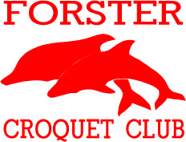
GOLF CROQUET CARNIVAL
4 days of golf croquet
Sunday 20th March to Wednesday 23rd March 2016
Handicap Doubles and Singles
Initially, limit 4 players per club
Handicaps 0-10
Entry Fee $40.00
Entries close 26th February 2016
Lunch available each day

Tournament Manager:
Mary Greig – 6555-9226
Email: forstercroquetclub@gmail.com

