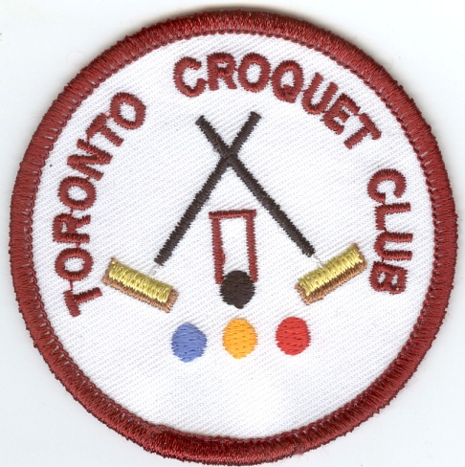

**TORONTO CROQUET CLUB INC. will be hosting the CNSW inaugural**

**GOLF DOUBLES GOLD BROOCH TOURNAMENT**

**Monday 29th - Wednesday 31stAugust, 2016**

**At: Ron Hill Oval, Straight Drive, Toronto 2283**

**Email address: torontocroquetclub@yahoo.com.au**

**Entry Requirement: Div.1 player (Handicap 0-4)**

**with a Div.2 player (Handicap 5-8)**

**ENTRY FEE: $30 PER TEAM**

**Morning and afternoon tea will be provided**

**Lunch can to be purchased each day**

**Practice: Sunday 28th August, 3-5 p.m.**

**Dinner at Toronto Workers’ Club: 28th August, 6.00 p.m.**

**CLOSING DATE: 19th August, 2016**

**Tournament Manager: Bill Munns, 02 49 530331, Mob. 0422 066 943**

Registration on standard CNSW Entry Form,

(on-line registration available soon)