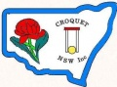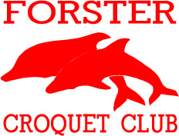

**2016 Host Club for CNSW Inc.**

**DIVISION 1**

**GOLF SINGLES AND DOUBLES**

**Forster Croquet Courts, Lake St, Forster**

**Sunday 14th to Thursday 18th August 2016**

**Singles $30 pp. Doubles $30 per team.**

**Morning and Afternoon tea provided**

**Lunch available for purchase daily**

**Registration and practice: Saturday 13th August:**

**2pm to 5pm**

**Closing Date: Friday 29 July 2016**

**To enter online click** [**here**](http://www.thedufferstice.com/tournaments-by-category/gc/croquet-nsw-gc/77-cnsw-division-1-doubles) **for Doubles**

**and** [**here**](http://www.thedufferstice.com/tournaments-by-category/gc/croquet-nsw-gc/78-cnsw-division-1-singles) **for Singles.**

**Club Contact: forstercroquetclub@gmail.com**