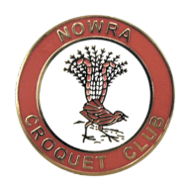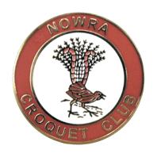
2016 Host Club for CNSW Inc.
DIVISION 3
Golf Singles and Doubles
Bomaderry Sporting Complex, 127 Cambewarra Rd Bomaderry
Monday 22nd to Friday 26th February 2016
Singles $30 pp. Doubles $30 per team.

Morning and Afternoon tea provided
Lunch available for purchase daily

Registration and practice: Sunday 21st: 2pm to 5pm

Closing Date: 5th February 2016
Registration on standard CNSW Entry Form,
or click for on-line registration for doubles or singles

Club Contact: nowracroquetclub@hotmail.com

