

CROQUET N.S.W.

ASSOCIATION CROQUET

BRONZE SINGLES CHAMPIONSHP

Monday 29th February to Friday 4th March 2016

This event will be hosted by and played at

Strathfield Croquet Club

50 Redmyre Road, Strathfield

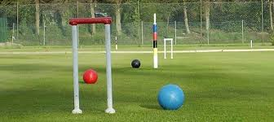

All entries to CNSW by 12 February 2016

Morning Tea provided.

Tournament Manager; Heather Smallbone

Heather.smallbone@gmail.com

To register online, click [here](http://www.thedufferstice.com/tournaments-by-category/ac/81-81-cnsw-bronze-singles)